INDEX

A. USING GIT: How to Start Development And Bug fixes In IDAM………………………………………………………………………………………………..2

B . USING GIT: How to Start Development And Bug fixes In IDAM on already created remote branch…………………………………….10

C. Resources ………………………………………………………………………………………………..………………………………………………………………………………..17

1. USING GIT: How to Start Development And Bug fixes In IDAM

NOTE: If u faced “SSL certificate problem: self signed certificate in certificate chain” kind of issue in git command then placed ‘-c http.sslVerify=false’ just after git (without single qoutes).

Example:

git -c http.sslVerify=false clone <https://devops.jio.com/JioMobilityAndEnterprise/IDAM/_git/dataMigrationProducts>

1. Open git bash terminal and Create directory.

Command: mkdir newDirectoryName; cd newDirectoryName

Example: mkdir gitpractice; cd gitpractice

References:

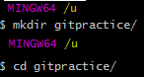

1. Clone master branch code from git remote repository !

Command: git clone remote_repo_link

Example: git clone <https://devops.jio.com/JioMobilityAndEnterprise/IDAM/_git/dataMigrationProduct>

References:



1. Now, create branch for development and bug fixes. (cd dataMigrationProduct )

Command: git branch branchName

Example: git branch newBranchForBugFixed

Reference:



1. Switch to your above created branch.

Command: git checkout branchName

Example: git checkout newBranchForBugFixed

Reference:

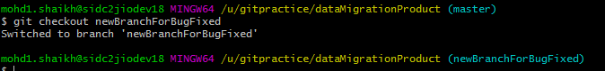

1. Now write your code here and commit those changes to Your local git repo also. ( . -> represent all content of current directory, used in below command)

Adding content of working directory to stage Area:

Command: git add filename

Example: git add .

Reference:



Commit content to local git repo:

Command: git commit filename –m “enter ur commit message here”

Example: git commit . –m “enter ur commit message here”

Reference:

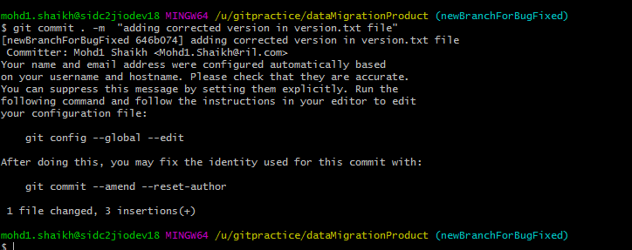

1. [OPTIONAL] Important Commands. ( . -> represent all content of current directory, used in below command)

Display Status Of Working Directory:

Command: git status filename.

Example: git status .

Reference:

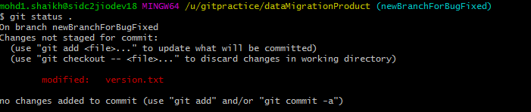

To track the difference between changes made on a file.

Command: git diff filename

Example: git diff .

Reference:

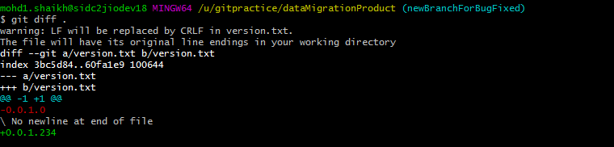

1. Done With Your development. Great ! Please push your branch to remote git repo.

Command: git push origin BranchName

Example: git push origin newBranchForBugFixed

Reference:

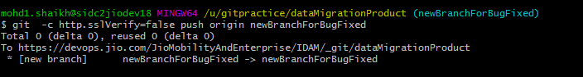

Your branch name should reflect on remote git repo.

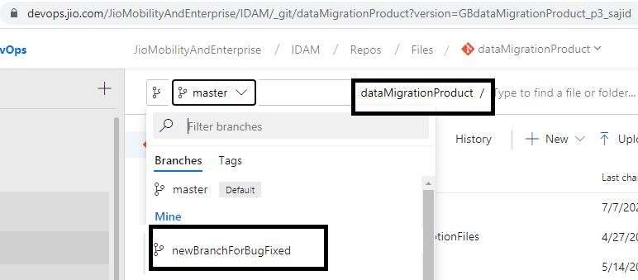

1. Now raise a review request.
2. After getting approval from PR, please do merge your code into master.

Switch to master branch:

Command: git checkout master

Reference:

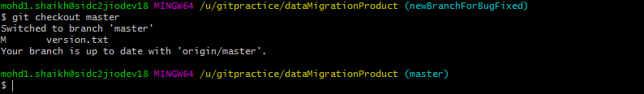

Merge with your branch with Master branch:

Command: git merge branchName

Example: git merge newBranchForBugFixed

Reference:

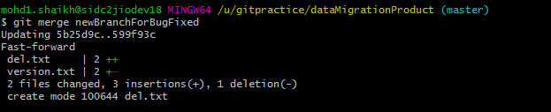

Special Case: If conflict found while merging then please resolve those conflict manually

by opening a files in code editor.

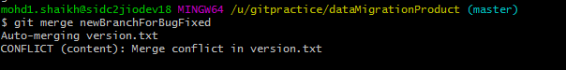

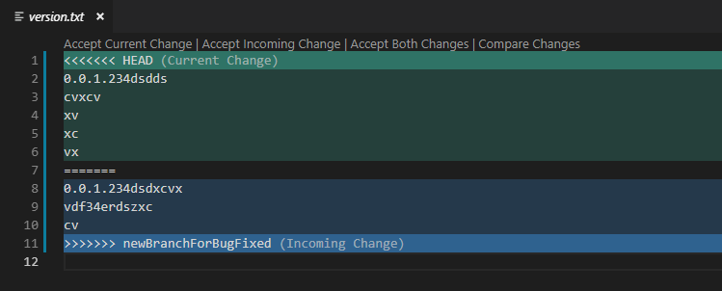

1. After merging branch to master, push master code base to remote repository.

Command: git push origin master

Reference:

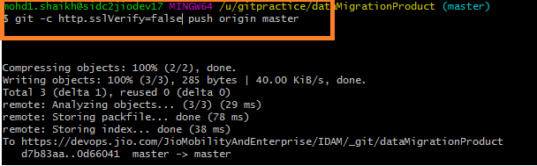

1. Hey, You did a great Job! Please have a smile and Delete Your branch from remote repository.

Command: git push origin --delete branchName

Example: git push origin --delete newBranchForBugFixed

Reference:

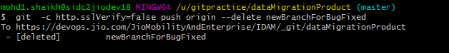

B. USING GIT: How to Start Development And Bug fixes In IDAM on already created remote branch

NOTE: If u faced “SSL certificate problem: self signed certificate in certificate chain” kind of issue in git command then placed ‘-c http.sslVerify=false’ just after git (without single qoutes).

Example:

git -c http.sslVerify=false clone <https://devops.jio.com/JioMobilityAndEnterprise/IDAM/_git/dataMigrationProducts>

1. Open git bash terminal and Create directory.

Command: mkdir newDirectoryName; cd newDirectoryName

Example: mkdir gitpractice; cd gitpractice

References:



1. Clone already created remote branch code from git remote repository !

Command: git clone –b banchName remote_master_repo _link

Example:

git clone -b newBranchForBugFixed <https://devops.jio.com/JioMobilityAndEnterprise/IDAM/_git/dataMigrationProduct>

References:



1. Now, go to the created directory.

Command: cd branchCreatedDirectory

Example: cd dataMigrationProduct

Reference:

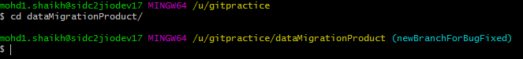

1. Now write your code here and commit those changes to Your local git repo also. ( . -> represent all content of current directory, used in below command)

Adding content of working directory to stage Area:

Command: git add filename

Example: git add .

Reference:



Commit content to local git repo:

Command: git commit filename –m “enter ur commit message here”

Example: git commit . –m “enter ur commit message here”

Reference:



1. [OPTIONAL] Important Commands. ( . -> represent all content of current directory, used in below command)

Display Status Of Working Directory:

Command: git status filename.

Example: git status .

Reference:



To track the difference between changes made on a file.

Command: git diff filename

Example: git diff .

Reference:



1. Done With Your development. Great! Please push your code changes to remote branch repo.

Command: git push origin BranchName

Example: git push origin newBranchForBugFixed

Reference:



Your commit should reflect on remote git branch repo.

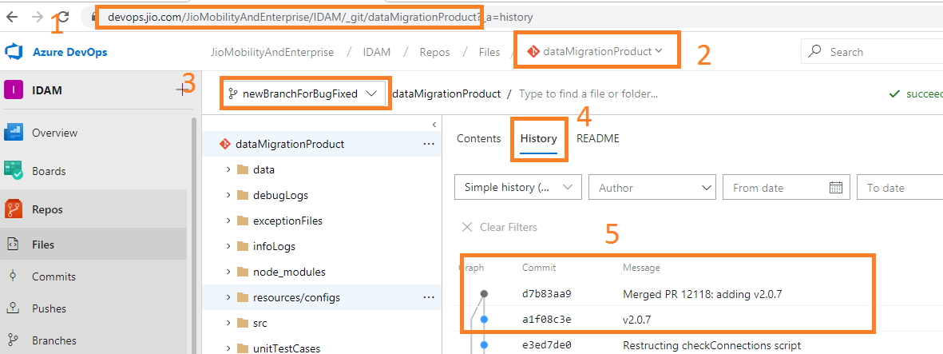

1. Now raise a review request.
2. After getting approval from PR, please do merge your code into master.

Switch to master branch:

Command: git checkout master

Reference:



Merge with your branch with Master branch:

Command: git merge branchName

Example: git merge newBranchForBugFixed

Reference:



Special Case: If conflict found while merging then please resolve those conflict manually

by opening a files in code editor.





1. After merging branch to master, push master code base to remote repository.

Command: git push origin master

Reference:



1. Hey, You did a great Job! Please have a smile and Delete Your branch from remote repository.

Command: git push origin --delete branchName

Example: git push origin --delete newBranchForBugFixed

Reference:



1. Resources:

Very Useful Article to Understand GIT

[2 minutes Read] <https://training.github.com/downloads/github-git-cheat-sheet.pdf>

[5-8 minutes Read] <https://dzone.com/articles/top-20-git-commands-with-examples>

[5-8 minutes Read] <https://gitimmersion.com/lab_12.html>

[1-2 hours Read] <https://git-scm.com/book/en/v2>

Alternative for above documentations:

[2 hours] <https://www.youtube.com/playlist?list=PLu0W_9lII9agwhy658ZPA0MTStKUJTWPi>

[Optional: How internally Git store data, checksum and its encryption SHA-1 mechanism]

[1 hours] <https://www.youtube.com/watch?v=DjOk0jnqsLk&t=145s>